1. Introduction
Agriculture is the backbone of many developing countries, including Nepal. Farmers often rely on middlemen to sell their produce, resulting in reduced income and unfair pricing. Customers also face difficulty in getting fresh produce directly from farmers at a reasonable rate. To solve this problem, we propose Farmo, a mobile application that directly connects farmers and customers. The app allows farmers to list their crops and vegetables, and customers can browse available products, compare prices, and place orders directly removing middlemen from the supply chain. Farmo have built-in wallet for farmer in it. Farmer’s earning will automatically load to wallet and they can withdraw money anytime from their wallet to personal wallet like E-Sewa, Khalti and Namaste Pay or in their bank account.

2. Aim and Scope

Aim:
- The main aim of the Farmo project is to create a digital platform that directly connects Nepali farmers and consumers by eliminating middlemen, ensuring fair pricing for farmers, and providing fresh, quality agricultural products to consumers.

Scope:
- The platform enables farmers to register, list products, and sell directly to consumers without middlemen.
- Consumers can browse products, place orders, and rate both farmers and goods.
- Admins manage user verification, monitor transactions, and generate system reports.

3. Objective
- To enable farmers to list and sell crops via a mobile app.
- To allow consumers to make payments securely using wallets or banks.
- To empower admins with tools for user verification and transaction monitoring.

4. Study of the Previous Systems
- Farmers sold their products through middlemen or local markets, often receiving low prices and delayed payments.
- There was no centralized digital platform for direct interaction, product tracking, or transparent rating between farmers and consumers.
- Website of Business house to selling crops are available in market.

5. Current Problems and Proposed Solutions

Current Problems:
- Farmers earn less because middlemen take most of the profit.
- Consumers pay high prices but still don’t get fresh products.
- No direct link between farmers and buyers, causing mistrust.
- Farmers have limited market reach and no proper online platform.
- Lack of transparency, consumers don’t know the source of their food.

Proposed Solutions:
- Farmers can upload and sell products directly through a simple mobile App. By this they can eliminate middleman.
- Consumers can order fresh products directly from farmer through mobile app in reasonable price.

6. High level requirements

6.1 Functional Requirements
- User Registration & Login
- Farmers and consumers must be able to create an account and log in.
- Farmer Profile Management
- Farmers can add or update their personal and farm details.
- Product Upload
- Farmers can upload product details with photos, videos, price, quantity, produced date, etc.
- Product Browsing
- Consumers can view products uploaded by farmers.
- Search & Filter
- Consumers can search products by name, category, or location.
- Order Placement
- Consumers can order products directly from farmers.
- Location Sharing
- Consumers can share their location or tell address where to deliver.
- Notifications
- Users receive updates about orders and also suggestion of new products according to his usage.
- Admin Panel
- Admin can manage users, products, product category and system activity.

6.2 Non-Functional
- Usability
- The app should be simple, clean, and easy to use.
- Security
- User data, passwords, and product details must be safe.
- Compatibility
- The app should run on most Android phones.

6.3 Requirement Prioritization Table
S.N. | Requirement | Priority | Description
1. | Farmer registration & product listing | High | Core feature to allow farmers to upload and sell goods directly.
2. | Consumer registration & ordering | High | Essential for buyers to browse, order, and purchase products.
3. | Farmo Wallet | High | Essential for transaction.
4.. | Rating & feedback system | Medium | Builds trust and transparency between farmers and consumers.
5. | Notifications & alerts | Medium | Keeps users updated on orders, offers, and product availability.
6. | Admin verification & reporting | Medium | Helps maintain system integrity and monitor activities.
7. | Delivery tracking | Low | Adds convenience but can be handled by third-party logistics initially.
8. | Advanced analytics/dashboard | Low | Useful for insights but not critical in the first phase.
Table 6.3: Requirement Prioritization Table

7. Design

7.1 Methodology
Rapid Application Development (RAD) is a software development methodology that emphasizes quick prototyping and iterative delivery. It focuses on building functional components rapidly through repeated cycles of designing, building, demonstrating, and refining. RAD is used because it enables fast user feedback, reduces development time, and allows teams to adjust requirements dynamically. By involving users throughout the process, RAD ensures the final product aligns closely with real-world needs while maintaining flexibility and speed.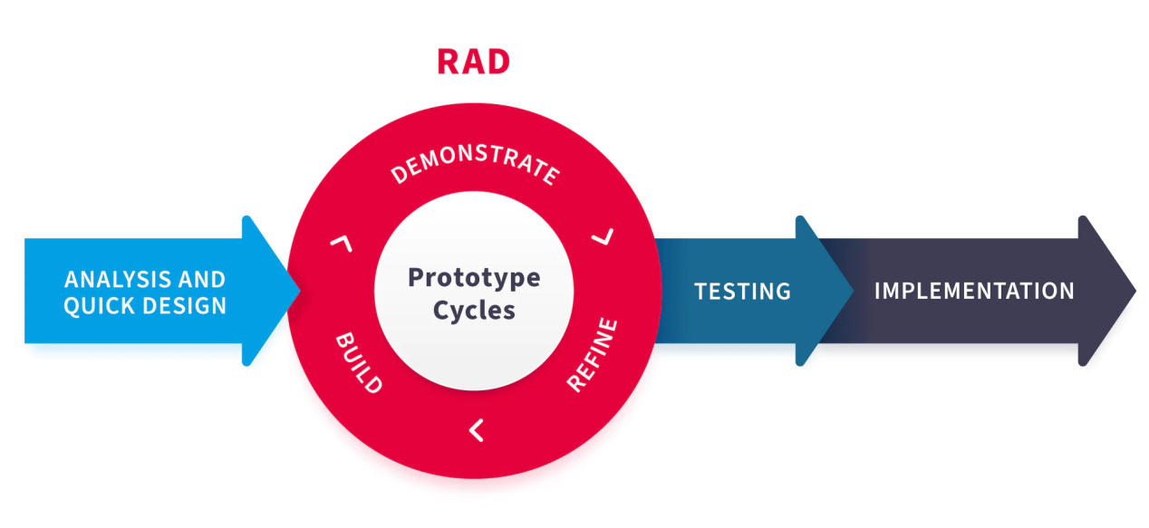

Fig 7.1: RAD Methodology

7.2 Architectural Diagram
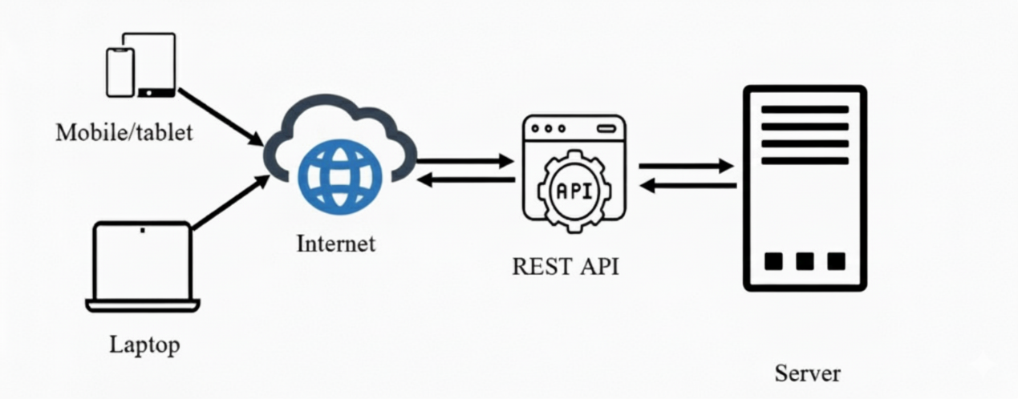

Fig 7.2: Architectural diagram

7.3 Schema Diagram
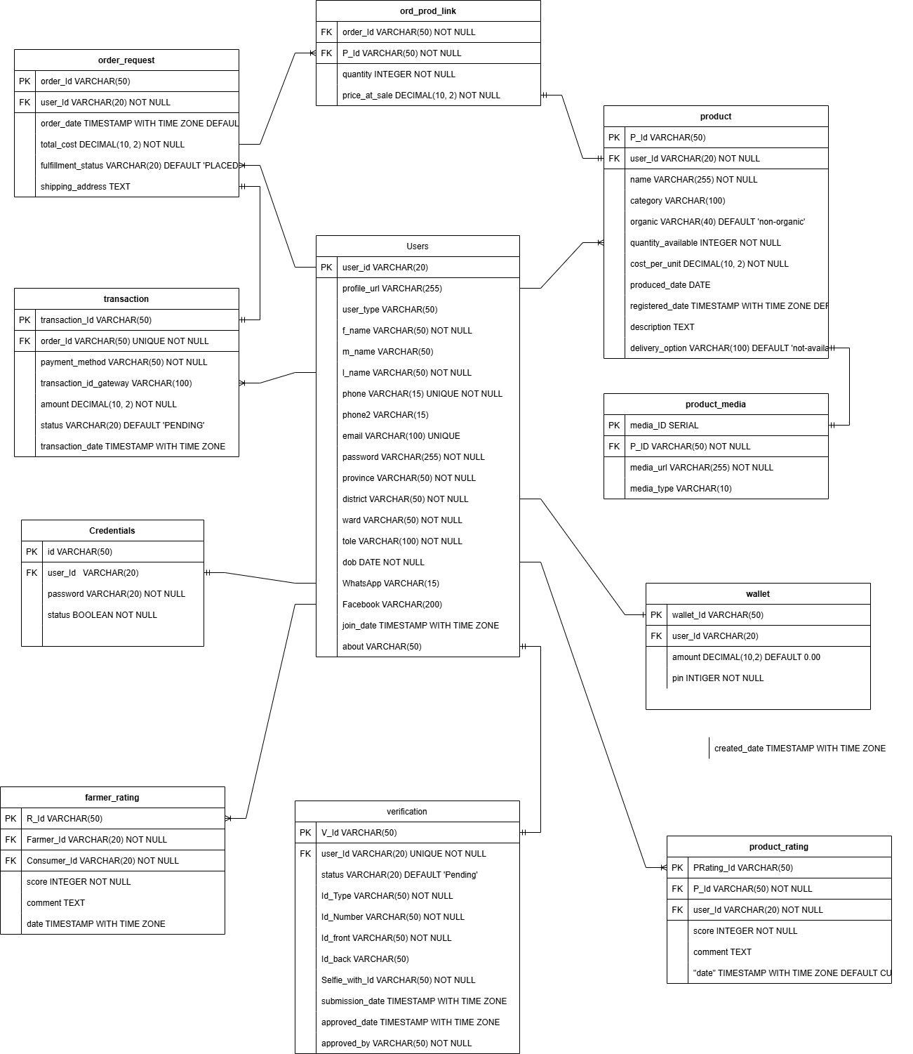
Fig 7.3: Schema diagram

7.4 Use Case Diagram

7.4.1 Use case diagram for Admin
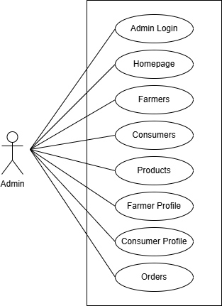
Fig 7.4.1: Use Case diagram for Admin

7.4.2 Use case diagram for Farmer/Consumer
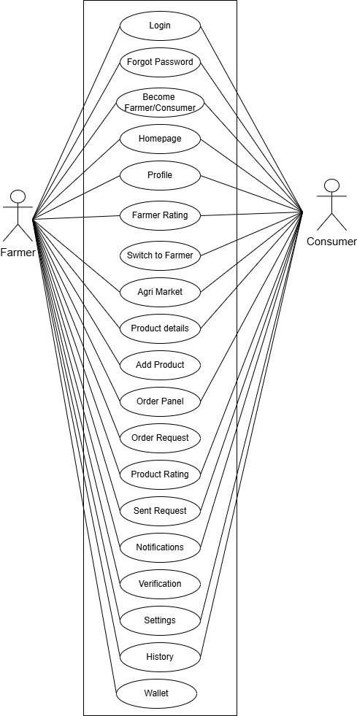
Fig 7.4.2: Use Case diagram for Farmer/Consumer

7.5 DFD Diagram

7.5.1 DFD Level 0
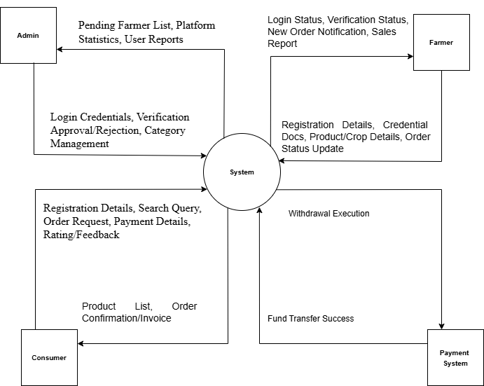
Fig 7.5.1: DFD Level 0 Diagram

7.5.2 DFD Level 1
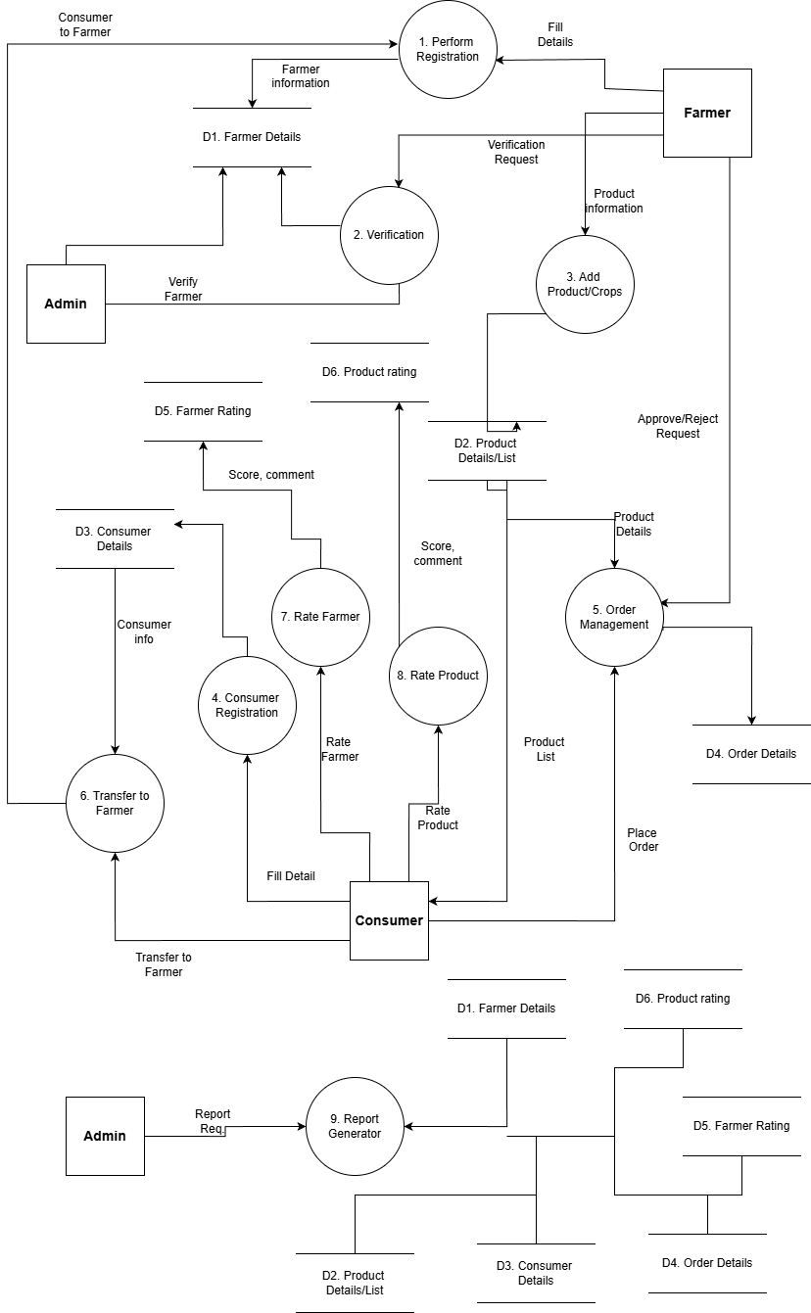
Fig 7.5.2: DFD Level 1 Diagram

Budget

Budget Detail
The estimated budget for developing the farmer-to-consumer system is approximately NPR 154,400. It covers frontend and backend development, mobile app creation, database setup, UI/UX design, hosting, and documentation. The budget also includes a one-time Google Play Console fee for app publishing. By using open-source tools like Django, PostgreSQL, and Android Studio, the team ensures cost-efficiency while delivering a complete and testable prototype.

8.2 Budget Breakdown
Items | Description | Cost (Rs.)
1. Frontend Development | UI/UX design, web interface, farmer/consumer dashboards | 22,000
2. Backend Development | APIs, business logic, order processing, rating system | 65,000
3. Database Setup | Schema design, product/user/order tables, backups | 5,000
4. Mobile App Development | Android app for farmers and consumers | 40,000
5. UI/UX Design | Designing Figma prototypes, Use Case/DFD flows. | 5,000
6. Web Hosting | Cloud server, domain, SSL, uptime monitoring | 10,000
7. Google Play Console | One-time developer fee ($25) to publish your Android App. | 3,400
8. Report Printing | Requirement docs, DFDs, final report, presentation | 4,000

Table 8.2: Budget Breakdown

9. Project Time Schedule
The project work is divided into various activities which will be carried out as per given schedule:
Activities | 2025  Nov-Dec |  |  |  | 2025-2026  Dec-Jan |  |  |  | 2026  Jan-Feb
Activities | Week |  |  |  | Week |  |  |  | Week
 | 1 | 2 | 3 | 4 | 5 | 6 | 7 | 8 | 9 | 10
Feasibility Study
Proposal submission
Proposal Defense
System design & Specification
Coding & verification
Testing and Refining
Mid-term Defense
Final testing
Documentation
Final presentation

Table 9: Project time schedule

10. Conclusion
The proposed system bridges the gap between farmers and consumers by offering a direct, transparent, and user-friendly digital platform. It empowers farmers to showcase and sell their products fairly, while enabling consumers to access fresh goods at reasonable prices. By eliminating middlemen, enhancing communication, and expanding market reach, the system promotes trust, efficiency, and sustainability in the agricultural supply chain. With well-defined hardware, software, and technology requirements, the project is both feasible and impactful for rural development.

11. References
[1] | Nepalilnfopedia, "Nepali Infopedia," [Online]. Available: https://nepaliinfopedia.com/list-of-food-crops-in-nepal/. [Accessed 19 11 2025].
[2] | Daraz, "Daraz," [Online]. Available: https://www.daraz.com.np/. [Accessed 15 11 2025].
[3] | Wikipedia, "Wikipedia," [Online]. Available: https://en.wikipedia.org/wiki/List_of_most_valuable_crops_and_livestock_products. [Accessed 20 11 2025].
[4] | Microsoft, "Github," [Online]. Available: https://docs.github.com/en. [Accessed 15 11 2025].
[5] | D. S. Foundation, "Django," [Online]. Available: https://docs.djangoproject.com/en/5.2/. [Accessed 20 11 2025].
[6] | Google, "Andriod for Developer," [Online]. Available: https://developer.android.com/develop. [Accessed 20 11 2025].

